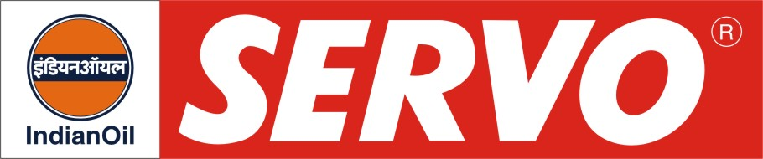
Anti Micropitting Gear Oil

Product | Kin. Viscosity cSt at 40 °C | VI Min. | Flash Point COC, °C Min. | Description / Application
Servomesh Plus 100  Servomesh Plus 150  Servomesh Plus 220  Servomesh Plus 320  Servomesh Plus 460  Servomesh Plus 680  Servomesh Plus 1000 | 90 – 110  135 – 165  198 – 242  288 – 352  414 – 506  612 – 748  900 - 1100 | 90  90  90  90  90  90  80 | 204  204  232  232  232  232  280 | Servomesh Plus Oils are advanced extreme pressure type industrial gear lubricants specially formulated to protect heavily loaded gears against micropitting. They meet performance requirement of Flender AG, AGMA 9005-D95, US Steel 224, DIN 51517 CLP, David Brown S1.53.101, SEB 181-226. They provide extended component life, excellent wear protection and improved protection from micropitting fatigue.

