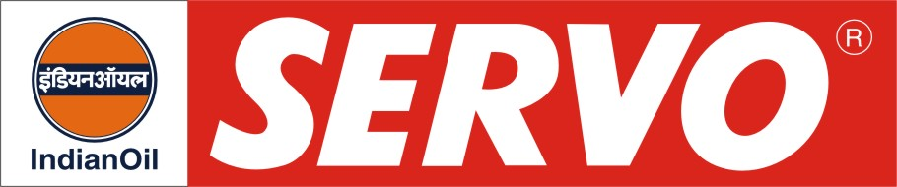

Coning Oil

Product | Kin. Viscosity cSt at 40 °C | VI Min. | Flash Point COC, °C Min. | Description / Application
Servoconing Oil  Servoconing 14 | 17 - 20  12 - 15 | 95  105 | 180  150 | These are specially formulated antistatic coning oils. They are recommended for use in Textile Industry as finishing agent. They are high refined, light coloured, low viscosity mineral oil based products containing suitable emulsifier, antistatic, friction reducing and anti-splashing agents to minimize the oil dosage during coning and twisting operation. They provide excellent lubricity to filaments and reduce friction during operation.

