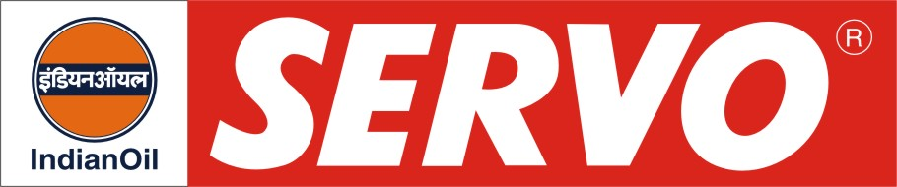

Anti-Micropitting Synthetic Gear Oils

Product | Kin. Viscosity cSt at 40 °C | VI Min. | Flash Point COC, °C Min. | Description / Application
Servosyngear 220 Plus  Servosyngear 320 Plus  Servosyngear 460 Plus  Servosyngear 680 Plus | 198 – 242  288 - 352  414 - 506  612 - 748 | 140  145  145  150 | 240  240  240  240 | Servosyngear Plus Oils are synthetic industrial gear lubricants which provide higher protection from micropitting fatigue. They have excellent thermal and oxidation stability and provide extra protection against wear, rust and corrosion. They are recommended for lubrication of gears working under heavy or shock load conditions and which may be subjected to micropitting. Their natural high VI and low pour point make them suitable for continuous all whether applications. Servosyngear Plus are approved by Flender against specification 06/12/2005/REV.9 and are suitable for wind mill gear boxes.
Servosyngear AMP 150  Servosyngear AMP 220  Servosyngear AMP 320  Servosyngear AMP 460 | 135 – 165  198 – 242  288 – 352  414 – 506 | 150  155  155  150 | 230  230  230  230 | Servosyngear AMP Oils are fully synthetic industrial gear oils designed to provide optimum equipment protection and oil life under extreme conditions of load and temperature. They are specially recommended for applications that may be subjected to micropitting especially highly loaded units and extreme temperature environments. These can be used for lubrication of plastic extruder boxes and modern highly loaded gear boxes used in paper, steel, oil, textile and cement industries. They meet DIN: 51517 Part 3 for CLP fluids. Servosyngear AMP is approved by Flender against Specification of 06/12/2005/REV.9 and is suitable for wind mill gear boxes.

