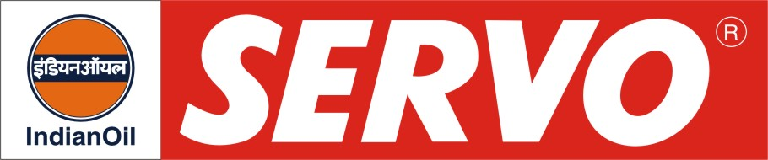
Hydraulic-cum-Machine Tool Way Oils

Product | Kin. Viscosity cSt at 40 °C | VI Min. | Flash Point COC, °C Min. | Description / Application
Servoway H 32  Servoway H 57  Servoway H 68  Servoway H 68 BD | 29 – 35  54 – 60  62 – 74  64 - 72 | 90  90  90  90 | 194  198  200  200 | Servoway H oils are combined hydraulic and machine way lubricants. These oils possess adequate lubricity to eliminate stick-slip and chatter under moderate load conditions and at the same time serve as hydraulic media in non-critical systems. Servoway H 32 meets ASLE standard W 150 and Cincinnati Milacron specification P-53. These oils are exclusively recommended for machine tools, which have combined hydraulic and way lubrication systems. Servoway H oils are not recommended for critical hydraulic systems or as a substitute for Servoway oils. Servoway H 68 BD exceeds the Indian requirement of minimum 70% biodegradability for ECO MARK.

