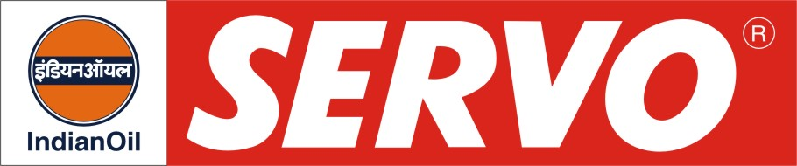

Morgan Bearing Oils

Product | Kin. Viscosity cSt at 40 °C | VI Min. | Flash Point COC, °C Min. | Description / Application
Servosteel 220  Servosteel 257  Servosteel 320  Servosteel 381  Servosteel 460  Servosteel 521  Servosteel 680 | 198 – 242  250 – 280  288 – 352  370 – 400  414 – 506  500 – 550  612 – 748 | 90  90  90  90  90  90  85 | 230  232  250  262  262  280  240 | Servosteel oils are premium quality bearing oils possessing superior oxidation and thermal stability. These oils separate from water quickly and have excellent film strength property to minimise wear in roll-neck bearings of steel mills. Servosteel oils meet requirements of Morgoil bearing lubricant specified by Morgan Construction Co., U.S.A. These oils fully meet performance requirements of IPSS: 1-09-001-81.
Servosteel 220 Plus  Servosteel 257 Plus  Servosteel 320 Plus | 198 – 242  255 – 265  288 – 352 | 95  95  95 | 230  232  250 | Servosteel Plus oils are superior quality Non-EP type steel mill bearing oils which provide outstanding water separation, good resistance to thermal degradation and oxidation and protection against rust and corrosion. They meet the advanced Morgan Specification requirement (of March 2002) and also IPSS: 1-09-001 -81.
Servosteel EP 100  Servosteel EP 150  Servosteel EP 220  Servosteel EP 381  Servosteel EP 460 | 90 – 110  135 – 165  198 – 242  370 – 400  414 – 506 | 95  90  90  90  90 | 220  230  230  230  262 | Servosteel EP oils are premium quality, extreme pressure, bearing and circulating oils which have very good load bearing ability in addition to excellent demulsibility characteristics. Servosteel EP oils are recommended for use in no-twist-rod mills and also in applications where severe load conditions are encountered.
Servosteel EP 100 Plus  Servosteel EP 150 Plus  Servosteel EP 220 Plus | 90 – 110  135 – 165  198 – 242 | 95  95  95 | 220  230  230 | Servosteel EP Plus oils are heavy duty bearing and circulating oils developed specially for the lubrication of bearings and gear boxes of ‘Wire Rod’ Mills. Formulated with superior hydro treated base oils and ashless additives, these oils meet the Morgoil Advanced Lubricant new oil revision 2.1 March 2002 specification including dynamic demulsibility endurance tests requirement. Servosteel EP Plus Oils possess high oxidation stability, superior anti wear characteristics and provide good protection against rust and corrosion.

