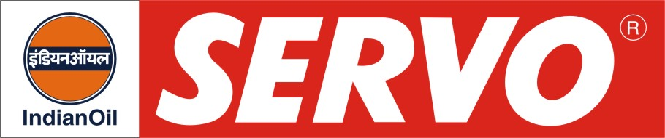
GRADES AVAILABLE – SERVO 2T SUPREME

DESCRIPTION
Servo 2T Supreme is low smoke semi-synthetic two stroke engine oil developed to meet the critical requirements of high performance two stroke engines manufactured by leading auto makers. It is blended from selected base stocks and additives to minimise spark plug fouling and preignition, prevent rusting, minimise deposit formation and provide protection against seizure, scuffing and wear. It contains a diluent for easy mixing with gasoline. Servo 2T Supreme is green dyed product.

APPLICATION

Servo 2T Supreme is recommended for lubrication of scooters, autorickshaws, motorcycles and mopeds operating on two stroke engines. The recommended dosage of Servo 2T Supreme is 20 ml of oil per litre of petrol.

PERFORMANCE STANDARDS

- JASO FC specifications.
- API TC Specification

Manufacturers Approval

- Servo 2T Supreme is approved by leading two stroke 2 and 3 wheelers manufacturers having petroil and oil injection lubrication system.

PERFORMANCE BENEFITS

- Low exhaust smoke
- Maintains engine cleanliness
- Minimises spark plug fouling
- Reduces port deposits and ring sticking
- Prevents seizure and scuffing
- Is easily pumpable by oil injection system

CHARACTERISTICS

Colour | Green
Kinematic Viscosity @ 40°C, cSt | 55-60
Flash Point (PMCC), °C, Min | 70
Sulphated ash % wt., | 0.078-0.095
Pour Point, Deg C | (-) 12

