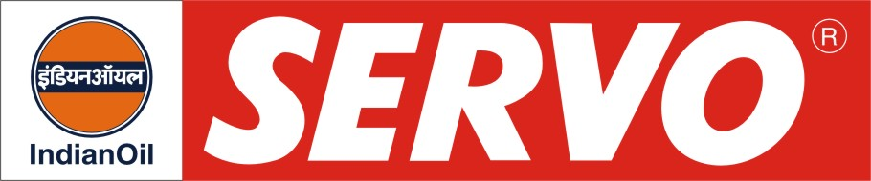
GRADES AVAILABLE - SERVO 4T ZOOM
DESCRIPTION

Servo 4T Zoom is high performance engine oil for 4 stroke 2/3 wheelers. This oil is a high viscosity index, 4 stroke engine oil.

APPLICATION

Servo 4T Zoom is recommended for new generation 4 stroke motorcycles, scooters and auto rickshaws.

PERFORMANCE STANDARDS

- JASO T 903 : API SJ / JASO MA 2

PERFORMANCE BENEFITS

- Maximum power output.
- Superior performance in terms of oxidation stability.
- Excellent wear protection at high temperatures and severe operating conditions.
- Outstanding overall engine cleanliness.
- Enhanced engine & gear life.
- Higher fuel efficiency.
- Potential oil drain period of more than 5000 Kms.

CHARACTERISTICS

SAE GRADE | 20W-40
Kin. Viscosity @ 100ºC, cSt | 13.5 – 15.5
Viscosity Index, Min. | 110
Flash Point, COC, ºC, Min | 200
Pour Point, ºC, Max | (-) 21
TBN, mg KOH/gm | 5.5 – 7.0

