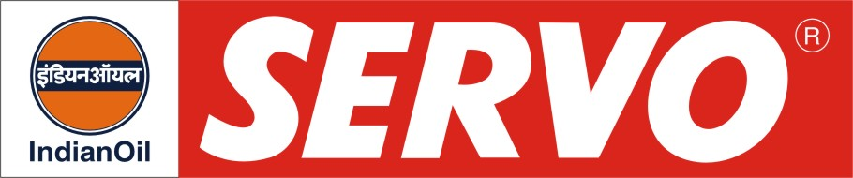
GRADES AVAILABLE - SERVO SUPER MG 5W-30/10W-30/10W-40/20W-40/20W-50

DESCRIPTION

Servo Super Multigrade Oils are blended from highly refined base stocks and balanced additive package containing shear stable VI improver, metallic detergent dispersant and anti-oxidant. These oils are formulated to meet lubrication requirements of both gasoline and diesel engines. Servo Super Multigrade Oils are red in colour and suitable for all seasons.

APPLICATION

Servo Super MG oils are recommended for

Modern passenger cars
- Naturally aspirated diesel engines operating under severe conditions.
- Supercharged diesel engines
- Vehicles encountering continuous start-stop operation.

PERFORMANCE STANDARDS

Meets the following specifications:

API SC/CC
US MIL-L-2104B
E-PL 1/E-DL 1 of IS:13656-2002

APPROVAL
Servo Super MG oils are approved by leading auto manufacturers like-
TELCO, Ashok Leyland , Mahindra & Mahindra, Bajaj Tempo, etc.

PERFORMANCE BENEFITS

Servo Super Multigrade Oils

- Enable easy low temperature starting
- Minimise fuel and oil consumption
- Give longer battery life
- Provide maximum protection to engine parts against rust and corrosion
- Give good high and low temperature performance in the engine
- Minimise wear of engine parts
- Ensure system cleanliness by holding contaminants in finely dispersed state

CHARACTERISTICS
SAE GRADE | 5W-30 | 10W-30 | 10W-40 | 20W-40 | 20W-50
Kinematic Viscosity cSt @ 100°C | 11-12 | 9.5 – 11.5 | 13.5 – 15.5 | 13.5 – 15.5 | 17.5 – 19.5
Viscosity Index, Min. | 150 | 135 | 140 | 110 | 125
Flash point (COC), °C Min. | 160 | 190 | 190 | 200 | 200
Pour Point, °C Max. | (-) 33 | (-) 27 | (-) 27 | (-) 21 | (-) 21
TBN, mg, KOH/gm | 9.2-12.0 | 6.5-8.5 | 4.5-6.0 | 4.2-8.0 | 4.5-6.0

