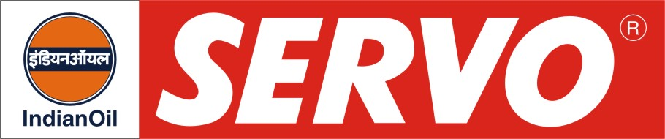
GRADES AVAILABLE – SERVO SUPERIOR 10W-30, 10W-40, 20W-40, 20W-50

DESCRIPTION

Servo Superior oils are high performance engine oils for new generation petrol and diesel vehicles. These oils are blended from high viscosity index base stocks and contain additives to meet the stated performance standards.

APPLICATION

Servo Superior Oils are recommended for new generation petrol and diesel cars. These oils are also suitable for existing passenger cars and four stroke two wheelers i.e. scooters and motorcycles.

PERFORMANCE STANDARDS

- API SF in gasolene and CD in diesel service.
- US Military MIL-L-46152 B
- E-PL 2 / E-DL 2 of IS:13656 - 2002

APPROVAL

- Hindustan Motors Ltd for all car models.
- Premier Automobiles Ltd. for 118 NE cars.
- Hero Honda Ltd.

PERFORMANCE BENEFITS

- Superior performance in terms of oxidation stability, dispersancy characteristics and energy efficiency.
- Excellent sludge control and extra wear protection at high temperatures and severe operating conditions.
- Outstanding overall engine cleanliness and also provide long engine life.
- Fuel savings and low oil top up.
- Catalytic Converter Compatible.

CHARACTERISTICS

SAE GRADE | 10W-30 | 10W-40 | 20W-40 | 20W-50
Kin. Vis. @ 100ºC, cSt | 9.5 – 11.5 | 14.0 – 15.5 | 13.5 – 15.5 | 17.5 – 19.5
Flash Point, COC, ºC, Min | 200 | 190 | 200 | 200
Pour Point, ºC, Max | (-) 27 | (-) 27 | (-) 21 | (-) 21
TBN mg KOH/gm | 6.2 – 8.3 | 8.0 – 10.5 | 5.5 – 7.5 | 5.0 – 7.0

