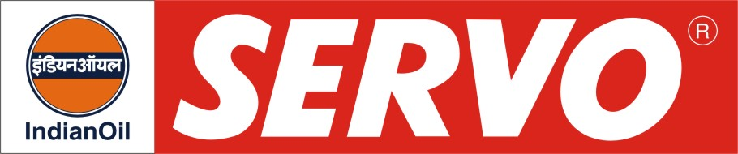
GRADES AVAILABLE - SERVO UNITRAC 30, 15W-30

DESCRIPTION
Servo Unitrac is a highly versatile tractor fluid and comes under the category of fluids commonly referred to as Super Tractor Oil Universal (STOU). It is carefully engineered with selected base stocks and performance additives to meet the diverse performance requirements of Engine, Wet Brakes, Power Take off Clutch, Hydraulic System, Transmission and Final Drive of modern new generation farm tractors.

APPLICATION
The parts of the tractor lubricated by STOU type of fluids are Engine, Transmission, Final Drive, Wet Brakes, Power Take Off (PTO) and Hydraulics. These oils can also be used for lubrication of off-highway machinery, industrial tractors and related equipment.

PERFORMANCE STANDARDS

Servo Unitrac meets the following specifications
- API CE/SF, US MIL-L-2104D
- MIL-L-46152B
- US MIL-L21260C
- ACEA E-3
Servo Unitrac also meets the following manufacturer’s approval
- Massey Ferguson : M 1139, CMS 1135
- Ford : M2C 159B & 159C & M2C 134D
- Case : MS 1207
- ZF : TE ML 07

PERFORMANCE BENEFITS

- Simplified lubricant inventory – one oil can be used for engines, hydraulics, transmission, wet brakes, PTO and final drive in farm tractors.
- Avoids use of wrong grade.
- Long fluid life
- All weather application.
- Available in mono and multigrade version

CHARACTERISTICS

SAE GRADE | 30 | 15W-30
Kinematic Viscosity, cSt @ 100°C | 10.0 – 10.5 | 10.0 – 11.0
Viscosity Index, Min. | 95 | 140
TBN mg KOH/gm | 9.5 – 11.5 | 9.5 – 11.5
Flash Point (COC), °C Min | 190 | 200
Pour Point, °C Max. | (-) 30 | (-) 30

