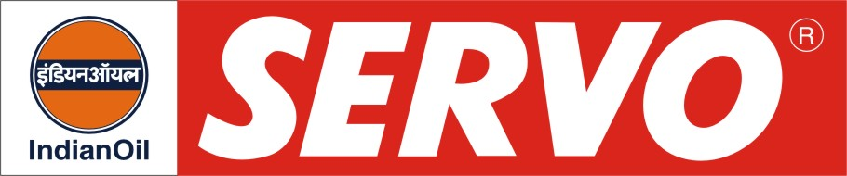
GRADES AVAILABLE - SERVOKOOL PLUS

DESCRIPTION

Servokool Plus is a triple action long life radiator coolant prepared from selected ingredients to meet the highest Japanese standard and is free from Amines, Borates, Nitrates and Silicates.

APPLICATION

Servokool Plus is recommended for passenger cars, light commercial vehicles, heavy vehicles and heavy earth moving equipment as a radiator coolant. For desired performance 30 parts of the fluid is to be diluted with 70 parts of distilled water in most of the vehicles.

PERFORMANCE BENEFITS

- Does not boil and vaporise in the hottest summer or freeze in swear winter.
- Prevents corrosion of radiator coolant and other parts.
- Increases cooling efficiency.
- Reduces maintenance costs and increases radiator life.

PERFORMANCE STANDARDS

- JIS K 2234-1994 specification.
- IS : 5759-1994
- MUL/Suzuki 17011M-50F 10F/1992

APPROVAL

Servokool Plus is approved by major automobile manufacturers.

CHARACTERISTICS

Appearance | Green liquid
Boiling Point, ºC, Min | 155
Freezing Point  30% Volume Solution, ºC  50% Volume Solution, ºC | (-) 14  (-) 34

