GRADES AVAILABLE - SERVOKOOL READY

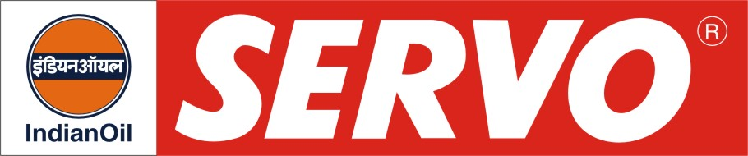

DESCRIPTION

Servokool Ready is a triple action long life ready to use radiator coolant diluted with purified water to meet the highest Japanese standard.

APPLICATION

Servokool Ready is recommended for passenger cars, light commercial vehicles, heavy vehicles and heavy earth moving equipment as a radiator coolant. Since it is a premixed & diluted coolant, which can be used straight away by topping up in the radiator or expansion bottle.

PERFORMANCE BENEFITS

- Bio-degradable and environment friendly.
- Free from Amines, Nitrites, Phosphates and Borates.
- Keeps the Engine Kool.
- Prevents corrosion of radiator coolant and other parts.
- Increases cooling efficiency.
- Reduces maintenance costs and increases radiator life.

PERFORMANCE STANDARDS

- JIS K 2234-1994 specification.

CHARACTERISTICS

Appearance | Clear Liquid
Colour | Light Blue
Boiling Point, ºC, Min | 104
Water Content %Wt. | 67-70

