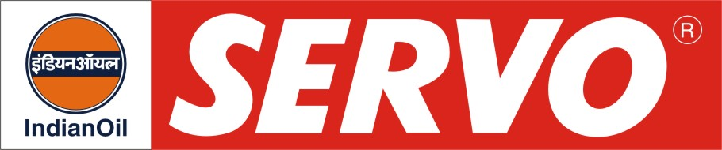
Special Open Gear Compound

Product | Kin. Viscosity cSt at 40 °C | VI Min. | Flash Point COC, °C Min. | Description / Application
Servotak 40  Servotak 40 NC | 1400-1600 at 40°C  1400 -1600 at 40°C | -  - | -  - | Servotak 40 is an open gear compound of bituminous base containing a non-inflammable diluent. It has good load carrying ability. This compound has a low pour point (-) 120C, which makes it suitable for use in low ambient temperature conditions. It is recommended for open gears working under heavy and shock loads and varying temperature conditions. Servotak 40 forms a strong adhesive film on the metal surface, which does not get squeezed out during usage and does not get hardened or chipped off under low temperature conditions. Servotak 40 NC contains non-chlorinated non inflammable dilutant.
Servo Gear Compound 30 | 575– 625 at 50°C | - | - | Servo Gear Compound 30 provides excellent film strength and load bearing ability to withstand high pressure encountered in heavily loaded open gears. This grade is recommended for lubrication of girth gears, open gears, cable and wire ropes. It is widely in use in various mining industries.

