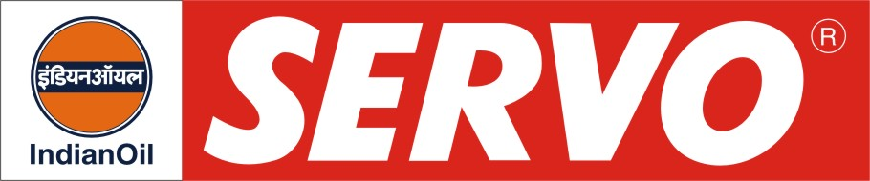

Synthetic Chain Lubricants

Product | Kin. Viscosity cSt at 40 °C | VI Min. | Flash Point COC, °C Min. | Description / Application
Servochainlube S 135  Servochainlube S 220 | 130 – 145  198 – 242 | 105  100 | 290  300 | Servochainlube S Oils are specially formulated synthetic product for lubrication of bearings, chains, slides and gears in industrial applications where air temperature often exceeds 260 deg C. They are suitable for use in ceramic paint, fiber glass plants, foundries steel mills, automotives plants, paper, rubber, textile industry etc.

