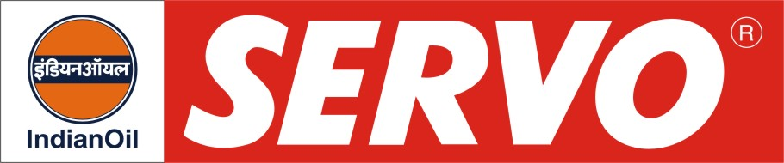
Synthetic Gear Oils

Product | Kin. Viscosity cSt at 40 °C | VI Min. | Flash Point COC, °C Min. | Description / Application
Servosyngear 32  Servosyngear 46  Servosyngear 68  Servosyngear 100  Servosyngear 150  Servosyngear 220  Servosyngear 320  Servosyngear 460  Servosyngear 680  Servosyngear 3200 | 29 – 35  42 – 50  62 – 74  90- 110  135 - 165  198 - 242  288 - 352  414 - 506  612 – 748  2900 - 3500 | 140  140  140  140  140  140  145  145  145  285(T) | 210  210  220  220  220  220  220  220  220  220 | Servosyngear oils are synthetic gear oils made of PAO based fluids and selected additives. They have excellent wear, corrosion and rust protection properties and enhanced oxidation stability. Their natural high VI combined with low traction co-efficient reduces power consumption and makes them energy efficient gear oils. They provide long equipment life. Servosyngear 3200 is specially developed for heavy duty traction gear cases of GE Locomotives.
Servosyngear HVI 220  Servosyngear HVI 320  Servosyngear HVI 460  Servosyngear HVI 680 | 198 – 242  288 - 352  414 - 506  612 - 748 | 220  220  220  220 | 260  260  260  260 | Servosyngear HVI Oils are Polyalkylene Glycol base synthetic gear lubricants having inherent high viscosity index and excellent thermal and oxidation stability. They are specially recommended for worm gear lubrication and are excellent lubricants for all types of gears, anti-friction and plain bearings working under most severe conditions.
Servosyngear 150 SF  Servosyngear 1000 SF | 135 – 165  900 – 1100 | 135  135 | 220  260 | Servosyngear SF Oils are synthetic hydrocarbon base industrial gear and bearing oils designed to provide outstanding performance in extreme service applications at high and low temperatures. They are compatible with bronze and provide better high temperature oxidation stability, antiwear properties, protection against rust and corrosion, extended oil life and reduced power consumption. Servosyngear 150 SF is specially recommended for lubrication of comber gear box in Textile industry. Servosyngear 1000 SF is recommended for anti-friction bearings of grinding rollers in cement mills.
Servosyngear 460 RR | 414 - 506 | 145 | 220 | Servosyngear 460 RR is a new technology synthetic type industrial gear oil recommended for heavily loaded worm gear systems working at elevated temperatures. It has high thermal stability and provides reduced wear, increased oil life and excellent resistant to oxidation and aging. It is specially developed for traction motor gear case of General Motor Locomotives.

