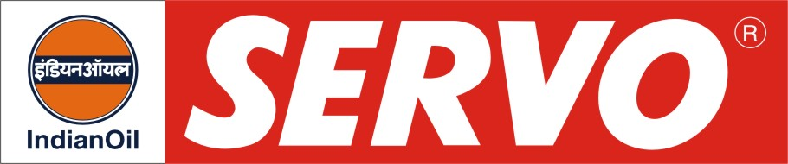
Textile Oils (Biodegradable/Synthetic )

PRODUCT | Kin. Viscosity cSt at 40 °C | VI Min. | Flash Point COC, °C Min. | Description / Application
Servotexshine BD 68  Servotexshine BD 100  Servotexshine BD 150 | 64 – 74  90 – 110  135 – 165 | -  -  - | 204  220  230 | Servotexshine BD oils possess good detergent qualities in addition to excellent oxidation resistance, anti-rust, anti-foam and anti-wear characteristics. These oils are eco-friendly and have 95% biodegradability per CEC-L-33-A-93.
Servosyntex 100 | 90 – 110 | 141 | 220 | Servosyntex 100 is a PAO based synthetic circulating oil for use in textile industry. This is multi-purpose oil for lubrication of gear transmission and bearings in weaving looms. It meets DIN 51517 part 3. Recommended for Sulzer Automatic Weaving Looms.
Servochaintex | 170 –190 | 105 | 250 | Servochaintex is a specially developed high temperature chain lubricant for lubrication of Hot Air stenter chains in textile industry. It is based on a unique type of base fluid and has excellent oxidation and thermal stability and low volatility ensuring low lubricant consumption. It is recommended for use in Textile machinery like hot air stenter clips, chains & sprockets, Heat setting systems, Thermic Systems, plywood and furnace industry and machineries operating under high temperature conditions.

