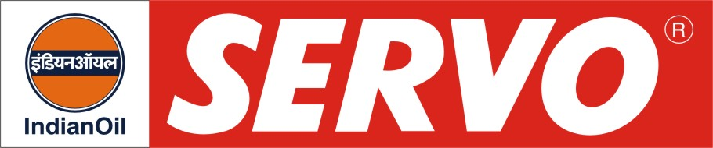
Textile Oils (Scourable Type)

PRODUCT | Kin. Viscosity cSt at 40 °C | VI Min. | Flash Point COC, °C Min. | Description / Application
Servotexshine 68  Servotexshine 100  Servotexshine 150 | 62 - 74  90 – 110  135 – 165 | 90  90  90 | 204  220  230 | Servotexshine oils are scourable type of textile oils designed for the lubrication of textile machinery particularly, the looms. These oils are fortified with special additives for providing excellent scourability properties, while imparting anti-rust, anti-foam and anti-wear characteristics. These oils have superior scourability characteristics of 97-99% stain removal as compared to the usual 27% scourability value achieved with the normally used mill lubricants.

