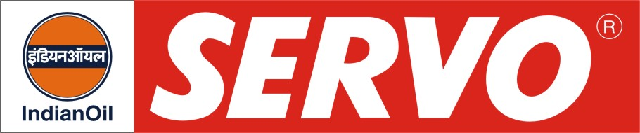
Circulating and Hydraulic Oils (Anti-wear Type)

PRODUCT | Kin. Viscosity cSt at 40 °C | VI Min. | Flash Point COC, °C Min. | Description / Application
Servosystem 22  Servosystem 32  Servosystem 46  Servosystem 57  Servosystem 68  Servosystem 81  Servosystem 100  Servosystem 150 | 20 – 24  29 – 35  42 – 50  54 – 60  62 – 74  76 - 86  90 – 110  135 – 165 | 95  95  95  95  95  90  90  90 | 160  190  200  210  210  210  210  230 | Servosystem oils are premium quality anti- wear type lubricants formulated with superior quality of hydro treated base stock. They provide long service life and are recommended for hydraulic and circulation systems of wide variety of equipments. These oils are also used for compressor crankcase lubrication, but are not recommended for lubrication of turbines and equipments having silver-coated components. These oils pass Vickers V-1O4C vane pump test and meet IS: 10522-1983 (Reaffirmed 2004) and IPSS 1-09-002 specifications.
Servosystem BD 46 | 42 – 50 | 125 | 204 | Servosystem BD 46 offers excellent biodegradability in addition to excellent load bearing capacity, anti-rust and anti-oxidant properties. It meets CETOP HETG (European Oil Hydraulic and Pneumatic Committee) specification and exceeds the minimum requirement of 70% biodegradability.
Servohydraulic Oil 32  Servohydraulic Oil 46  Servohydraulic Oil 68  Servohydraulic Oil 81  Servohydraulic Oil 100  Servohydraulic Oil 150 | 29 – 35  42 – 50  62 – 74  76 – 86  90 – 110  135 - 165 | 95  95  95  90  90  90 | 190  200  210  210  210  230 | Servohydraulic oils are high quality anti-wear type lubricants recommended for hydraulic systems and a wide variety of circulation systems of Industrial equipments. These oils are also used for compressor crankcase lubrication, but are not recommended for lubrication of turbines and equipments having silver-coated components. These oils pass Vickers V-104C vane pump test and meet IS: 10522-1983 (Reaffirmed 2004).

