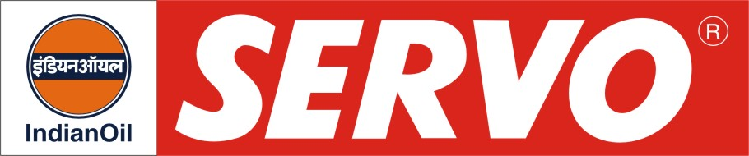
Open Gear Compound

Product | Kin. Viscosity cSt at 40 °C | VI Min. | Flash Point COC, °C Min. | Description / Application
Servocoat 110  Servocoat 120  Servocoat 140  Servocoat 170  Servocoat 170 T  Servocoat 190 | 80 – 120  200 – 250  400 – 550  710 – 760  740 – 810  900 - 1100 | -  -  -  -  -  - | 250  250  280  280  280  280 | Servocoat are open gear compounds having good load carrying ability and are recommended for open gear, wire rope and chain drive lubrication. Servocoat compounds are also for the lubrication of kiln tyres operating at high temperature in cement mills and chemical plants. These compounds should not be used in food processing industries. Servocoat 170 T has special tackiness additive and has been developed specifically to meet the requirements of Indian Railways.

