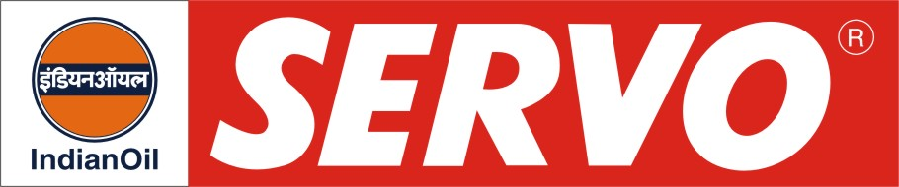
GRADES AVAILABLE - 606 MG Plus
DESCRIPTION
Servo RR oils have been developed to meet lubrication requirements of Generation IV Rail road engines in operation with the Indian Railways. These oils are blended using high quality base stocks having excellent thermal and oxidation stability. Special additives incorporated in these oils impart high degree of detergency, dispersancy coupled with the desired level of alkalinity to combat the ill effects of combustion products of high sulphur fuels.

APPLICATION

Servo RR 606 MG Plus is “Extra Performance” Generation IV Plus Multi grade oil component based specially designed for Indian Railways. Recommended for ALCO, GM & MAK Locomotives for passenger, goods and shunter service.

PERFORMANCE STANDARDS

Servo RR 606 MG Plus meets the following specification:

- Gen V reqt of Locomotive Maintenance Officers Association (LMOA), USA.
- General Motors Corporation, USA requirements of MI-1761C
- API CF
- Approved by RDSO, Lucknow.

PERFORMANCE BENEFITS

Servo RR oils
- Provide extended service life of rings and cylinder liners
- Give adequate protection to turbocharger bearings
- Keep engine parts clean
- Possess high alkalinity which helps to combat corrosive ill effect of sulphur present in the diesel fuel

CHARACTERISTICS
GRADE | Servo RR 606 MG Plus
SAE GRADE | 20W-40
Kinematic Viscosity cSt @ 100°C | 15.5 – 16.3
Viscosity Index, Min. | 110
Flash point (COC), °C Min. | 200
Pour Point, °C Max. | (-) 21
TBN, mg. KOH/g (Typical) | 17

