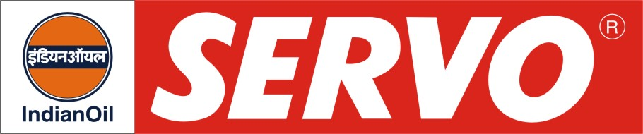
GRADES AVAILABLE – SERVOGEM RR 3

DESCRIPTION

Servogem RR 3 is a premium quality, lithium soap, multipurpose grease. The grease is manufactured from high viscosity index base oils and select additives with superior performance benefits.

APPLICATION

This grease is specially developed for the lubrication of antifriction bearings of railway axle boxes of locomotives and electric motors to give longer service life. Grease has also been evaluated for pinion and commutator end of traction motors of locomotives.

The grease has been also evaluated for wheel bearing applications for automotive purposes.

PERFORMANCE BENEFITS

- Excellent resistance to water washout
- Superior oxidation and structural stability
- High degree of antirust and anticorrosion properties.
- Give outstanding performance under varying operating conditions.
- Suitable for lubrication under sub-zero (-25°C) to reasonably high (140°C) temperature conditions.

PERFORMANCE STANDARDS

Meets specification of Association of American Railroads (AAR-M-942-81) with deviation in consistency and passes SKF Emcor corrosion test and WD-17-MISE-92 specifications.

APPROVAL:
Servogem RR 3 is approved by
- Railways (RDSO)
- Ashok Leyland

CHARACTERISTICS

NLGI GRADE | Servogem RR 3
Colour | Brown
Structure | Smooth
Soap Type | Lithium
Worked Penetration @ 25°C, (60 Strokes) | 220-250
Drop Point, °C, Min. | 180

