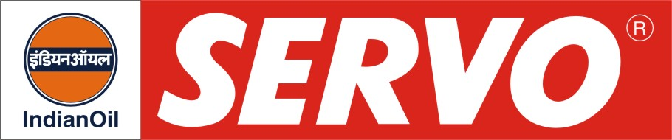

Turbine Oils

Product | Kin. Viscosity cSt at 40 °C | VI Min. | Flash Point COC, °C Min. | Description / Application
Servoprime 15  Servoprime 32  Servoprime 46  Servoprime 57  Servoprime 68  Servoprime 76  Servoprime 100 | 13 – 17  29 – 35  42 - 50  54 – 60  62 – 74  75 – 80  90 – 110 | 100  100  98  95  95  95  95 | 160  200  200  210  210  220  220 | Servoprime oils are premium turbine oils formulated with superior quality hydro-treated base stocks and possess exceptional thermal and oxidation stability, excellent demulsibility, air release property and resistance to foaming. These oils meet IS: 1012-2002, BS 489, General Electric GEK27070, Siemens (KWU) spec. TPS 9013 04 (KWU), GEK 28143A, GEK 32568C, GEK 101941A (for Servoprime 32) & GEK 32568A for Gas Turbine (for Servoprime 32) and BHEL turbine oil requirements. Servoprime oils provide long service life and are recommended for lubrication of steam, gas and hydraulic turbines and can be used in hydraulic systems requiring long life lubricant of outstanding properties.
Servoprime 32 T  Servoprime 46 T  Servoprime 57 T  Servoprime 68 T  Servoprime 76 T | 29 – 35  42 – 50  54 – 60  62 – 74  75 - 80 | 100  98  95  95  95 | 200  200  210  210  220 | Servoprime T oils are similar to Servoprime oils but in addition contain anti-wear additives. These oils have higher FZG ratings and meet the requirements of geared turbines. Servoprime T oils meet specifications of ALSTOM HTGD 90117, GEK 28143 and Siemens-TLV 901304 (KWU).
Servoprime 32 LP  Servoprime 46 LP  Servoprime 68 LP | 29 – 35  42 – 50  62 – 74 | 100  98  95 | 200  200  210 | Servoprime LP oils are low pour-point turbine oils formulated with superior quality hydro-treated base oils and have excellent oxidation stability and anti-rust and anti-foam characteristics. Recommend for low temperature applications like Rotoflow expanders and Turbo-compressors used in refrigeration applications.
Servoprime 32 LL  Servoprime 46 LL  Servoprime 68 LL | 29 – 35  42 – 50  62 – 74 | 100  98  95 | 215  215  215 | Servoprime LL oils are long life turbine oils with superior oxidation stability and improved anti-wear performance. These oils have potential for providing problem- free long life in turbines of modern power plants working under most severe operating conditions. Exceed the requirements of all National and International specifications and carries the approval of major OEMs like BHEL, Siemens etc.
Servoprime 32 A | 29 – 35 | 100 | 200 | Servoprime 32 A is specially designed turbine oil, with high anti-wear properties, formulated with superior quality hydro-treated base stocks. Recommended by GEC-Alstom for use in gas turbines against GEK 28143A specification.
Servoprime 15 G  Servoprime 32 G  Servoprime 46 G | 13 – 17  29 – 35  42 – 50 | 110  100  100 | 160  210  210 | Servoprime G oils are high anti-wear type turbine oil, formulated with superior quality hydro-treated base oils, specially designed to satisfy the demanding requirements of modern high output gas turbines including geared units. Exceed the specification requirement of ALSTOM HTGD 90117, GEK 32568F, and BHEL GT10198 and is approved by BHEL.

